Date: Bottle number:
Team members:
- Responsible for looking at the bottle:
- Responsible for controlling the experiment:
- Secretary 1 (Write down the data)
- Secretary 2 (Write the justifications):
Data collection

Data analysis
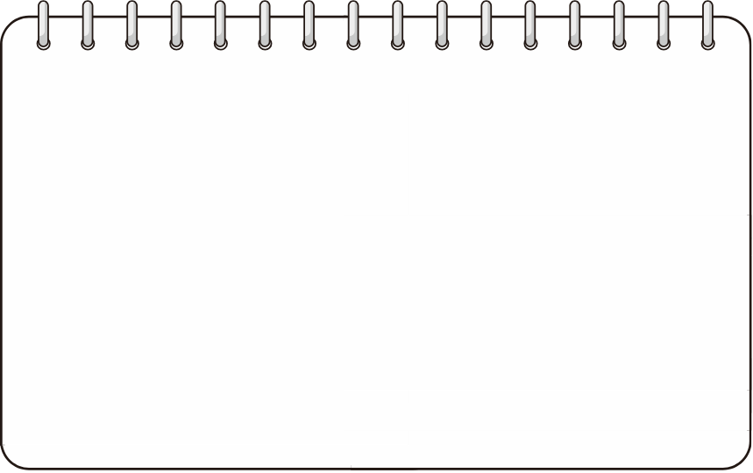
Hypotheses about the content
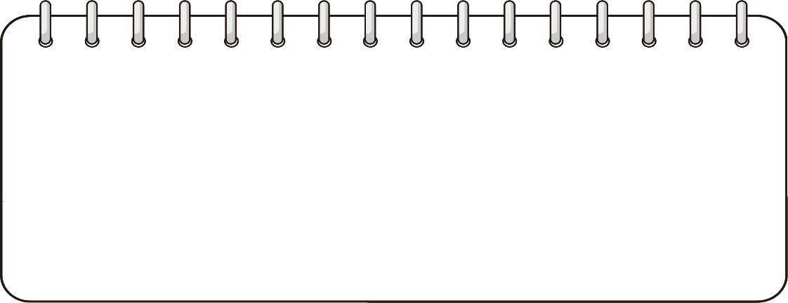
Confidence level
Mark where you would place your level of confidence in your hypotheses:
Gens segur Poc segur Bastant segur Totalment segur

